**LetsUpgrade Linux Administration Essentials Course Batch 1**

**Assignment Day 5 | 4nd December 2020**

Student Name: Kartick K

Email-id: [kartickkripa@gmail.com](mailto:kartickkripa@gmail.com)

**Assignment:**

1. Use ps to search for the “systemd” process by name.
   * Use ***“ps aux | grep -I systemd”***  to search for the process by name

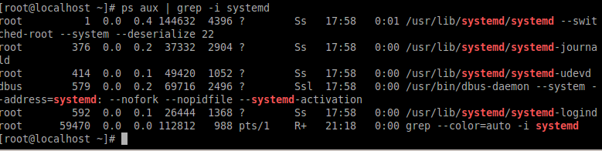

1. Find out your terminal name. Using your terminal name, use ps to find all processes associated With your terminal.
   * Use ***“w”*** command to see the list of users logged in the system
   * Use ***“ps-T”***  command to see the processes associated with a specific terminal.

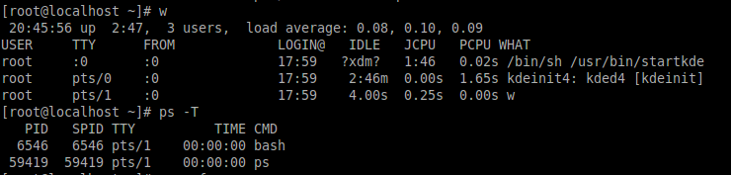

1. Check and note the process id of your shell(from the output of the above command). Also, note the parent process id of your shell.

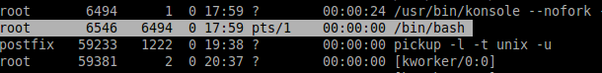

1. Start 3 instances of “sleep 123” as background processes.

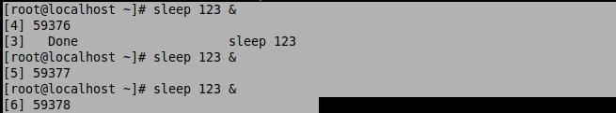

1. Check and note the process id’s of all sleep processes.
   * 59376 , 59377 , 59378 are the PID’s of the sleep processes.
2. Display only those three sleep processes in top. Then quit top.
   * To display the three process we use ***“top -p[PID]”*** command

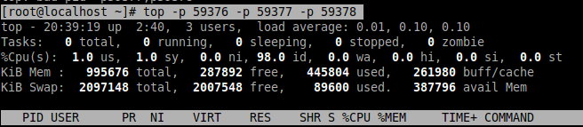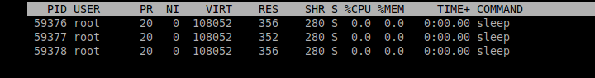

* Quit the top command by pressing ***“q”*** key.

